MODULE 4 – INTRODUCTION TO DBMS

LAB EXERCISES

17. PL /SQL Control Structure
Lab 1.
Write a PL / SQL block using an IF – THEN condition to check the department of an employee.
Ans.
Query IF – THEN condition
1. DELIMITER //

CREATE PROCEDURE check_department(in eid int)

BEGIN

DECLARE dept int;

SELECT dept_id INTO dept FROM employees WHERE emp_id = eid;

IF dept = 1 THEN

SELECT 'Employee belongs to HR Department' AS result;

ELSE

SELECT 'Employee belongs to another Department' AS result;

END IF;

END //

DELIMITER ;

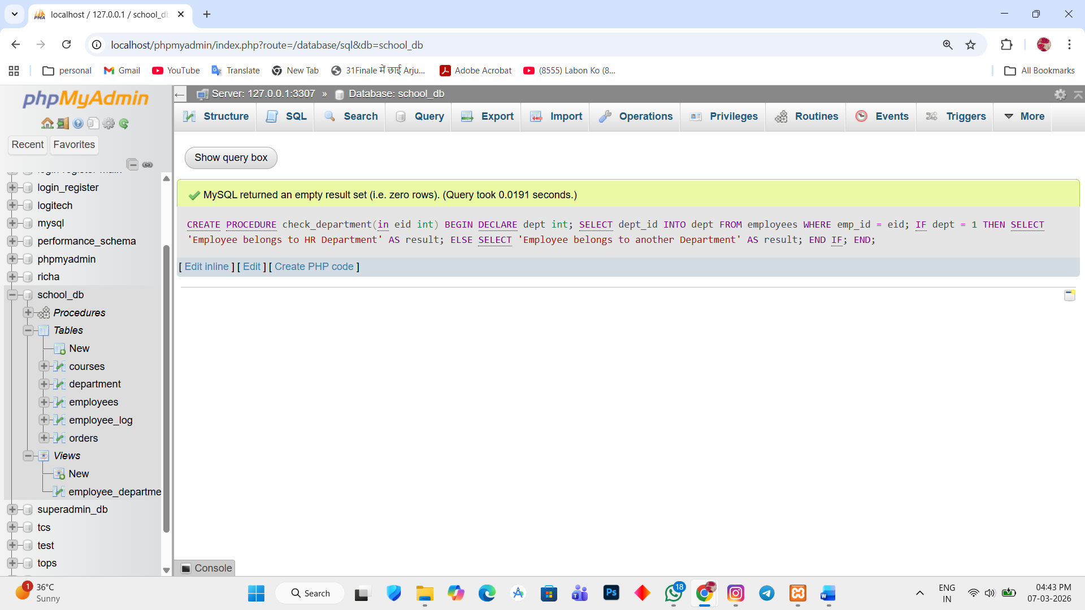

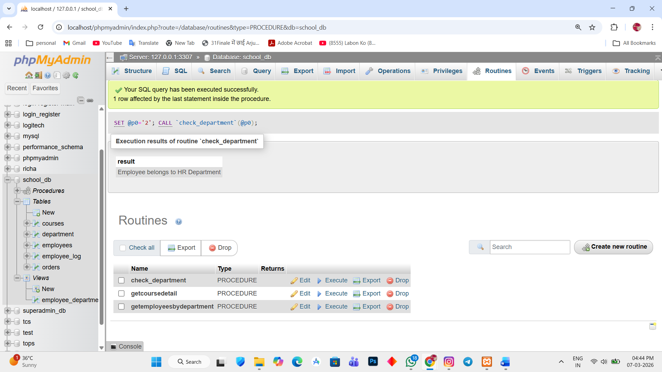

Lab 2.
Use a FOR LOOP to iterate through employee records and display their names.
Ans.
1. DELIMITER //

CREATE PROCEDURE display_employee_names()

BEGIN

DECLARE done int DEFAULT 0;
DECLARE empname varchar(255);

DECLARE emp_cursor CURSOR FOR SELECT emp_name FROM employees;

DECLARE CONTINUE HANDLER FOR NOT FOUND SET done = 1;

OPEN emp_cursor;

read_loop: LOOP

FETCH emp_cursor INTO empname;

IF done = 1 THEN
LEAVE read_loop;
END IF;

SELECT empname AS employee_name;

END LOOP;

CLOSE emp_cursor;

END //

DELIMITER ;
